Call for Research Projects:

Behavioral Science Research to Drive Environmental Impacts

Executive Summary
The most urgent environmental challenges of our time share one thing in common – to solve them, people must behave differently. Global understanding of human behavior is evolving quickly. New insights across economics, political science, evolutionary biology, social psychology, neuroscience, and design thinking have transformed our understanding of human behavior and decision-making. These evidence-based approaches provide new opportunities for tackling global conservation challenges.
Rare’s Center for Behavior & the Environment is providing small grants to support primary behavioral science research projects that provide insight into how to more effectively drive environmental behavior change. Proposed efforts should be completed by April 2024 and can address any of the most pressing environmental challenges facing the world, such as biodiversity conservation, climate change, land degradation, water pollution, waste management, and more.

Background
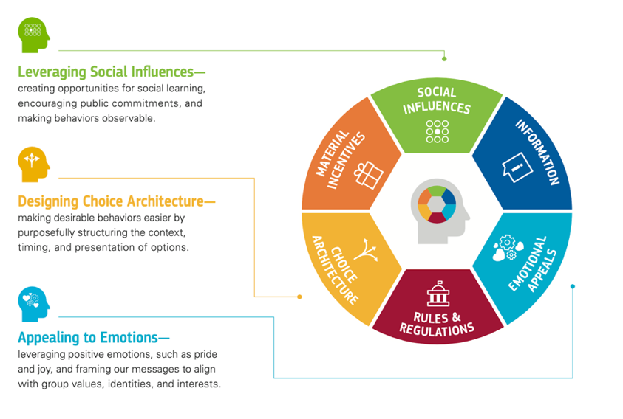
Behavioral science is a critical missing link in tackling some of the world’s greatest environmental challenges. This burgeoning field, which draws on the fields of social psychology, cultural anthropology, behavioral economics, neuroscience, and more, contains evidence-based approaches with demonstrated success. These insights and design methods offer breakthrough solutions for inspiring community action by tackling the core motivations and barriers behind the unsustainable behaviors. While some sectors have been quick to integrate behavioral insights, the environmental field is just starting to adopt, traditionally relying primarily on material incentives, knowledge/ awareness campaigns, and regulatory change. While these tools can be effective, results have demonstrated that they can be insufficient when not leveraged in a behaviorally informed way.
Figure 1: Expanded Toolkit with Levers for Behavior Change; Source: Rare’s Center for Behavior & the Environment

In order to complement the more commonly used ‘levers’ of material incentives, rules and regulations, and information, Rare’s Center for Behavior & the Environment (BE.Center) promotes a more complete toolkit for environmental practitioners, which integrates other key behavioral insights that are less commonly applied to these challenges. This expanded set of behaviorally informed strategies can be grouped into three categories: social influences, emotional appeals and choice architecture (see Figure 1). Learn more about the BE.Center’s levers and the evidence for their impact here.

Proposed Research Projects
Rare seeks to support primary research projects that provide novel insight into how behavioral insights may be applied in driving environmental impacts. Research may focus on any environmental challenge and may incorporate any suite of behavioral insights most applicable. This research should empirically test behavioral insights in the lab or field with clear implications for environmental practitioners’ intervention design.

Selected projects may also be asked to present findings at the BE.Center’s BE.Hive conference in 2024 (specific dates and location to be selected).

The total amount of grants allocated will be $75,000 and distributed to at least three grants. The projects will run from approximately May 2023 – April 2024.

About Rare & the BE.Center

Rare inspires change so people and nature thrive.

Conservation ultimately comes down to people – their behaviors toward nature, their beliefs about its value, and their ability to protect it without sacrificing basic life needs. And so, conservationists must become as skilled in social change as in science; as committed to community-based solutions as national and international policymaking. Rare and its partners in 50+ countries throughout these regions are committed to designing conservation programs that benefit both people and nature – ensuring that change is embraced and sustained.

In 2017, Rare launched the Center for Behavior & the Environment (BE.Center) to leverage the best insights from behavioral science and design thinking to tackle some of the most challenging environmental issues. Through partnerships with leading researchers and practitioners, we are translating the science of human behavior into practical solutions for conservationists and sustainability leaders worldwide. For additional background on the BE.Center, visit: https://behavior.rare.org/.

Detailed Specifications
Individuals and organizations interested in applying for research project grants should provide information on the following elements associated with their efforts:

- Research question(s): What is the question executing your study will answer? How will answering this question provide insight applicable for environmental practitioners?
- Sample: Who will participate in your study? How will you recruit them? How many of them? What is your justification for these choices?
- Study design: What are the methods and procedures you will use to collect your data? What is your justification for these choices?
- Analysis: How do you plan to analyze the data you collected (as detailed as necessary that someone else could follow your process and achieve the same results)? What is your justification for these choices?
- Ethical considerations: What ethical considerations arise in the course of your study? How will you ensure that these are adequately addressed? Are there any diversity and equity challenges, and if so, how will you address them?
- Experience: Who is your study team and what are their roles and affiliations? What is their relevant experience? What is the applicant(s)’s availability to run this project? (Note: You do not need to have more than one person completing this study to apply.)
- Budget: How much funding is required to implement this study? How will those funds be allocated?

Assumptions & Constraints
Applicants will have obtained all necessary approvals within their organizations (as relevant) and study locations to launch the projects.

Applicants will abide by the Belmont Report ethical principles for human subjects research of respect for persons, beneficence, and justice.

Applicants should include any costs in its budget that will be a part of regular project operations (telephone use, travel, etc.). The total project budget should reflect all costs associated with this work. Travel costs to present the findings at the next BE.Hive, if the organization is selected, do not need to be included here.

Terms and Conditions

The grants would run May 15, 2023 – September 30, 2024. Rare reserves the right to shift these dates as needed.

Evaluation Process & Selection Criteria
Rare’s team will evaluate proposed projects based on the selection criteria to identify the set of projects that will run over the following year. In addition to the overall best proposals, the Rare team may choose a portfolio of projects that represent different environmental sectors, behavioral insights, target audiences, implementation regions, etc.

Submitted proposals will be evaluated on the following criteria listed (in no particular order of priority):

- Addresses all requested elements
- The extent to which applicant’s proposed project fulfills this call’s overall goal and specifications
- An assessment of the project feasibility
- An assessment of the applicant’s ability to lead the project
- Overall cost of project

Rare may, at its discretion and without explanation to the prospective applicants, at any time choose to discontinue this call without obligation to such prospective applicants.

Submission Deadlines
All submissions for responding to this request must be submitted by email, as stated below, no later than: March 15, 2023

Rare anticipates notifying the selected projects by the end of April.

Submission Delivery Address
Submissions should be sent electronically to:
BE.Center Team
Rare, Inc.
behavior@rare.org

Rare’s physical offices are located at:
1310 N. Courthouse Road
Arlington, VA 22201 USA
Please do not mail any hard copies to the office.

Submission Questions and Clarifications
You may contact the BE.Center team if you have any questions or require clarification on any topics covered in this document: behavior@rare.org.

Applying Behavioral Insights to Drive Environmental Impacts

Please complete the following application form and submit to behavior@rare.org by March 15, 2023.

Project Overview
Abstract. Give a brief summary of your program. (875 characters max):

General Information
Lead Applicant Name:
Organization (if relevant): |  |  | Affiliation: | ☐Nonprofit ☐Government  ☐Business ☐University  ☐Individual ☐Other _________________
Email Address:
Street Address:
City: |  |  | State/  Province:
Postal code: |  |  | Country:

Context
Sectors impacted (select all that apply): ☐Biodiversity Conservation ☐Climate Mitigation ☐Water
☐Waste Management & Pollution ☐Land Management & Agriculture ☐Climate Adaptation/Resilience ☐Other
Describe the context in which you will conduct research. Please be specific where possible. (250 words max.)
Click here to enter text.

Experimental Design
What is the research question you seek to answer? How will answering this question provide insight applicable for environmental practitioners? (300 words max)
Click here to enter text.
Why did you select this topic and behavioral insight? (250 words max)
Click here to enter text.
Who is in your sample? What is your study sample size? How will you recruit these participants? Please explain your choices. (200 words max)
Click here to enter text.
How will you design your study? What are the methods and procedures you will use to collect your data? Please explain your choices. (300 words max)
Click here to enter text.
How will you analyze the data you collected? Please explain this process in as much detail as necessary for others to follow your process. Why did you choose this method? (500 words max)
Click here to enter text.

Team
Describe the project team. Who is leading it? What are their roles and affiliations. Please attach relevant CVs (500 words max)
Click here to enter text.
Share some of the key partners or stakeholders engaged in your project. (250 words max.)
Click here to enter text.

Ethics
What ethical considerations arise in the course of your study? How will you ensure that these are adequately addressed? How will you adhere to ethical practices and procedures? (250 words max)
Click here to enter text.

Are there any diversity and equity challenges, and if so, how will you address them? (250 words max.)

Click here to enter text.

Scalability
How do you think this work will translate across global contexts? (250 words max.)
Click here to enter text.

Budget
How much funding is required to implement this study?
Click here to enter text.
Please attach a budget articulating how those funds will be allocated. Major budget categories could include:
- Travel
- Meetings & Workshops
- Software & Equipment
- Other Direct Costs
- Indirect Costs (12.5% max, excluding contractors & consultants)

https://www.hhs.gov/ohrp/regulations-and-policy/belmont-report/read-the-belmont-report/index.html

